l

**Report On:**

Data visualization on Coronavirus Cases Dataset by Jupyter Book

(Anaconda)

**Course Code: CSE-317**

**Course Title: Software project-v**

**Submitted To:**

**Fariha Jahan**

**Department of CSE**

**Daffodil International University**

**Submitted** **By:**

**Group number: 5**

**Section: M**

**Daffodil International University**

**Date Of Submition: 07 -04-2021**

Group Member’s Name & ID

1. **Nayem Hasan**

**Id : 191-15-12498**

1. **Sayed Anwar Rifat**

**Id: 191-15-12927**

1. **Bipro Roy**

**Id: 191-15-12976**

1. **Khaza Numan**

**Id: 191-15-12918**

1. **Istiak Ahamed**

**Id: 191-15-12917**

1. **Eshfat Ara Esha**

**Id: 191-15-12909**

**-----------×××××××××----------**

**Github Link: https://github.com/istiak12917/Covid-19-Data**

**Project Title**

Coronavirus Cases Report

**Abstract:** This project is mainly for data preprocessing and building graphs with python. In other words, it has been shown how the total cases, total new cases and total total deaths of Corona virus according to the country has been shown and also 5 graphs have been shown here.

**Introduction:** Basically, here is csv file with the number of people infected total cases with the corona virus worldwide , the number of new cases and the number of total deaths.

**Methodology:** We wrote publications of the corona virus with jupyter note book(anaconda 3)that we collected using a database on the total cases, the number of new cases, and the amount of total deaths to the study design. We have used descriptive graphs statistics to classify and compare study designs over time.

**Graphs & Codes:**

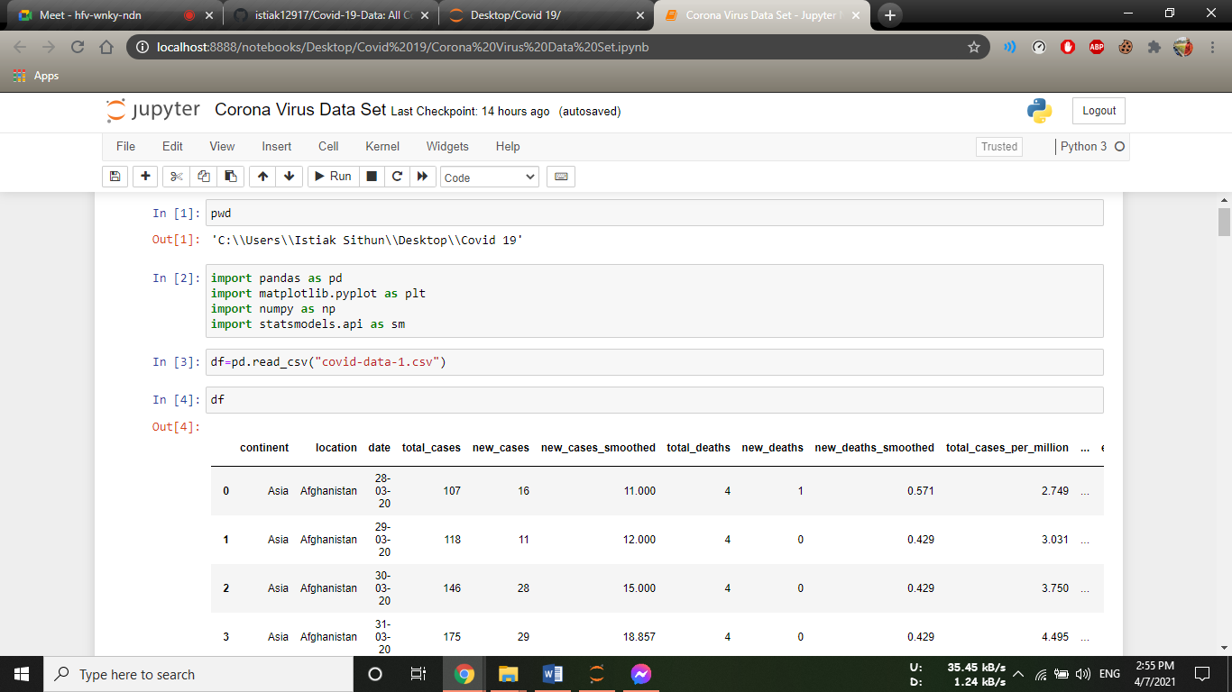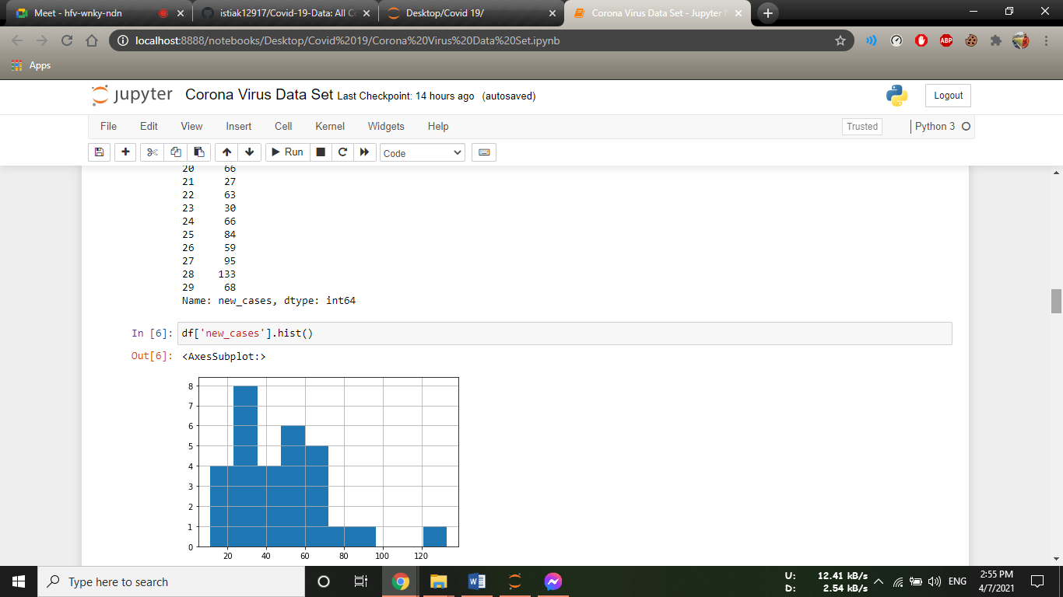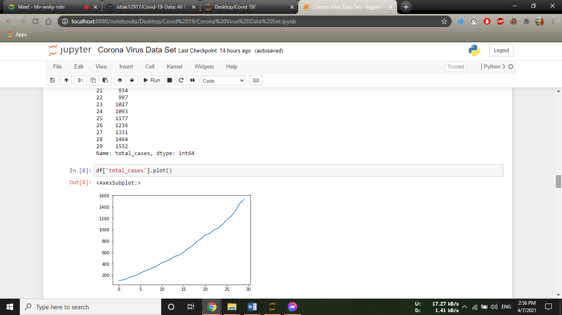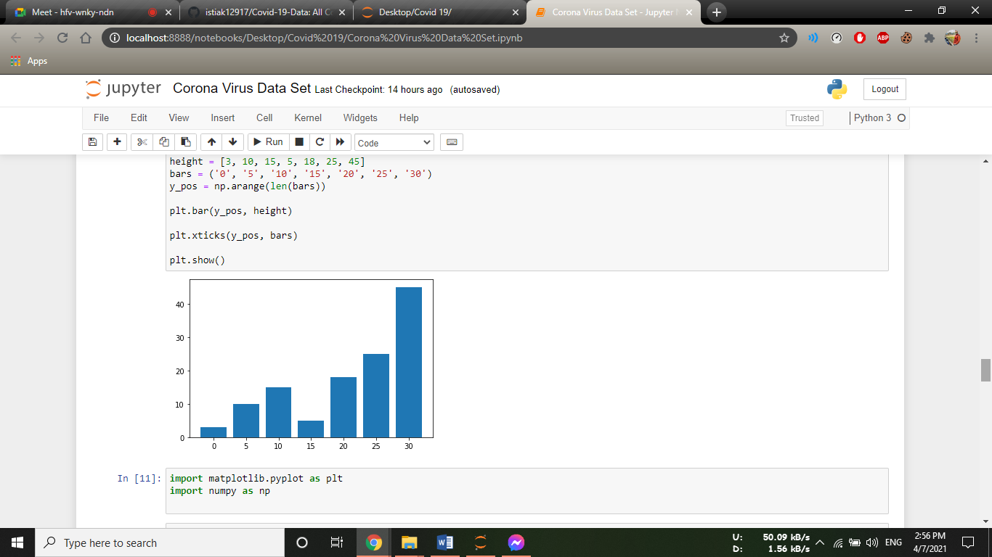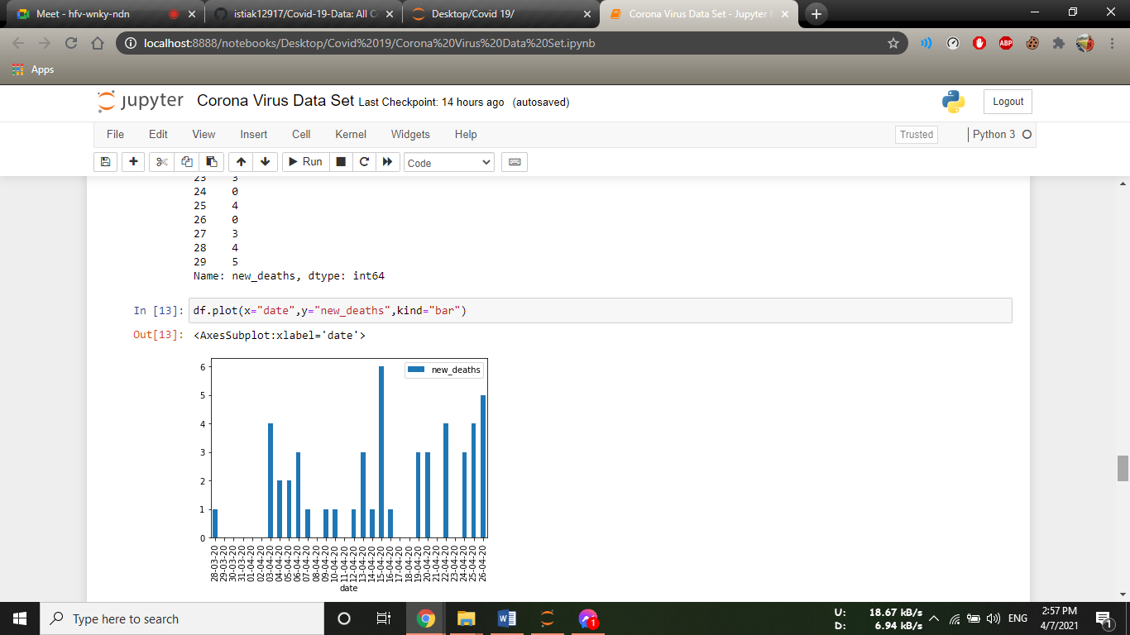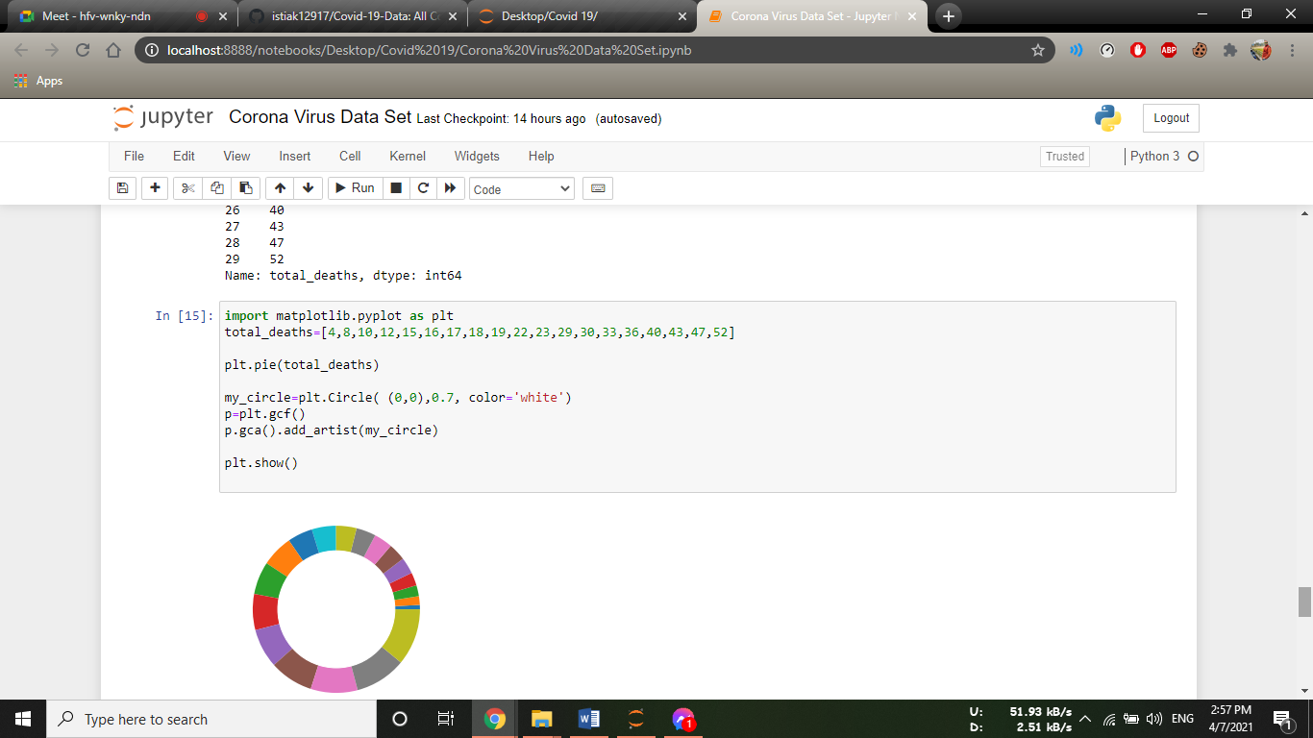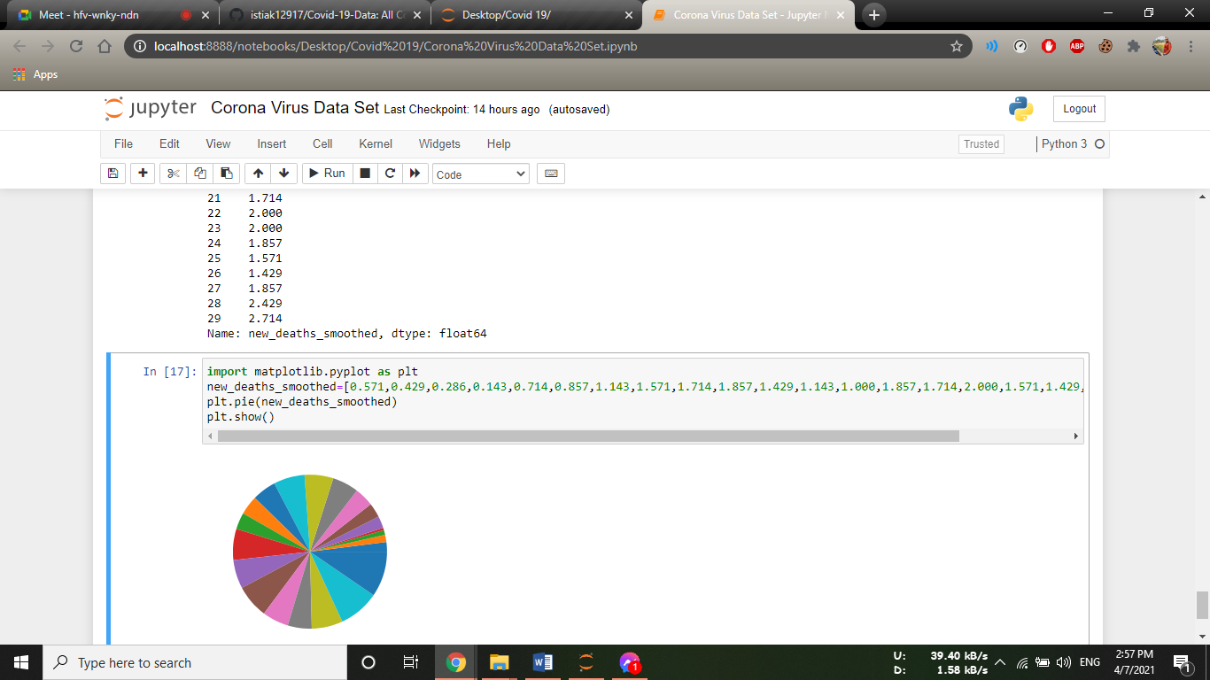

**Discussion**: The overall distribution of publications at the start of the covid-1 virus epidemics was similar. Epidemiological research was more commonly published than laboratory research and non-original contributions accounted for a substantial fraction of all publications for both infections. For both infections, case reports and case series, mathematical modelling and phylogenetic studies were prominent at the start of the epidemic, whereas analytical study designs, such as cohort and case-control studi.

Conclusion: The findings of this report shows how description of the types and timing of publications during outbreaks of emerging and re-emerging diseases can help us understand which types of public health questions we can answer and when. Further analyses of the generation and accumulations of research evidence during disease outbreaks could help to improve the public health response.